**Khuzama Yousaf**

**191AEB016**

**Before:**

root.geometry("250x400+300+300")

**Before:**

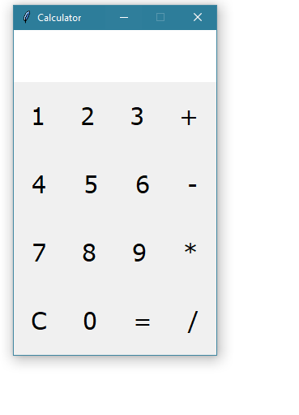

**After:**

root.geometry("500x500+300+300")

**After:**

